EXPERIMENTNO:13

Determinationandplottingofintinsicimpedanceandphase velocity ofvariousmedium
Aim:
Todetermineandplotintrinsicimpedanceandphasevelocityof variousmedium.

Softwarerequired:
- SCILABversion6.0.1

Program:
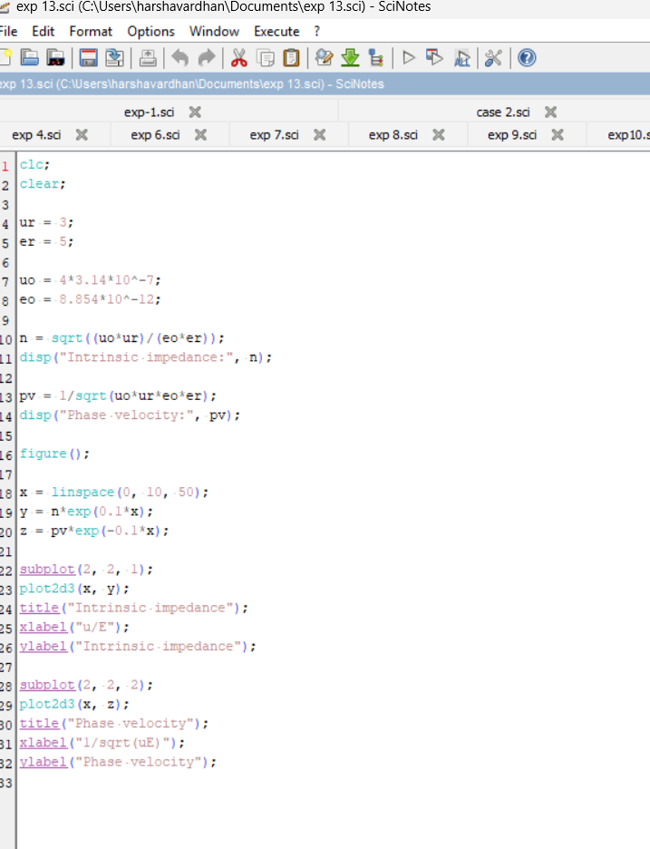

Output:

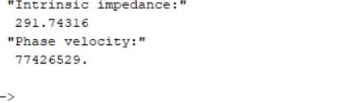

Theoreticalcalculation:
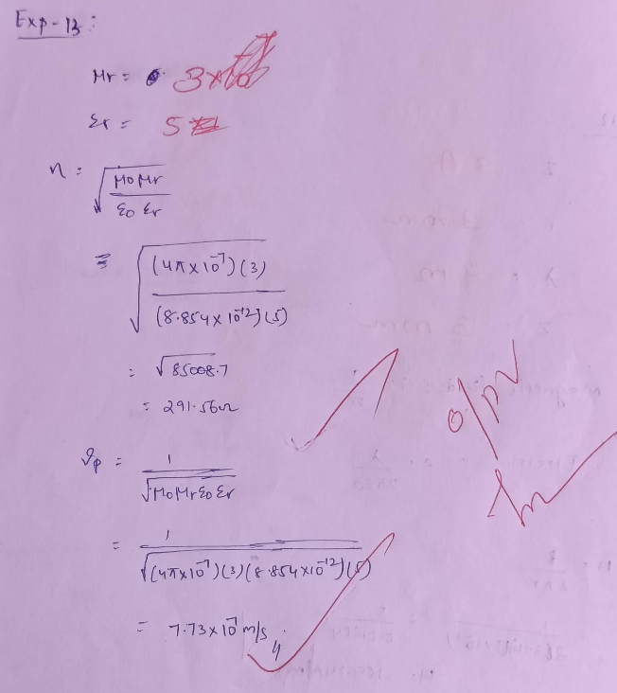
Case1:Todeterminetheintrinsicimpedanceandphasevelocityof electromagneticwavesinfreespace(vacuum).

Program:
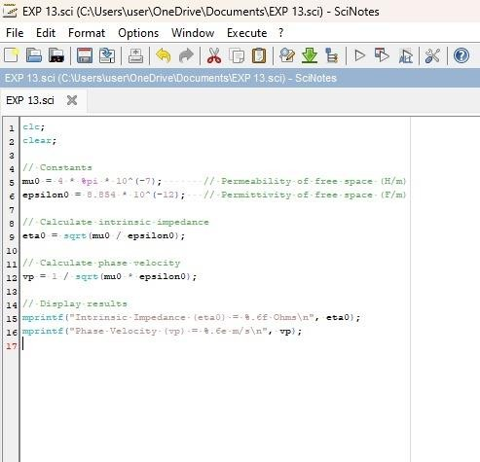

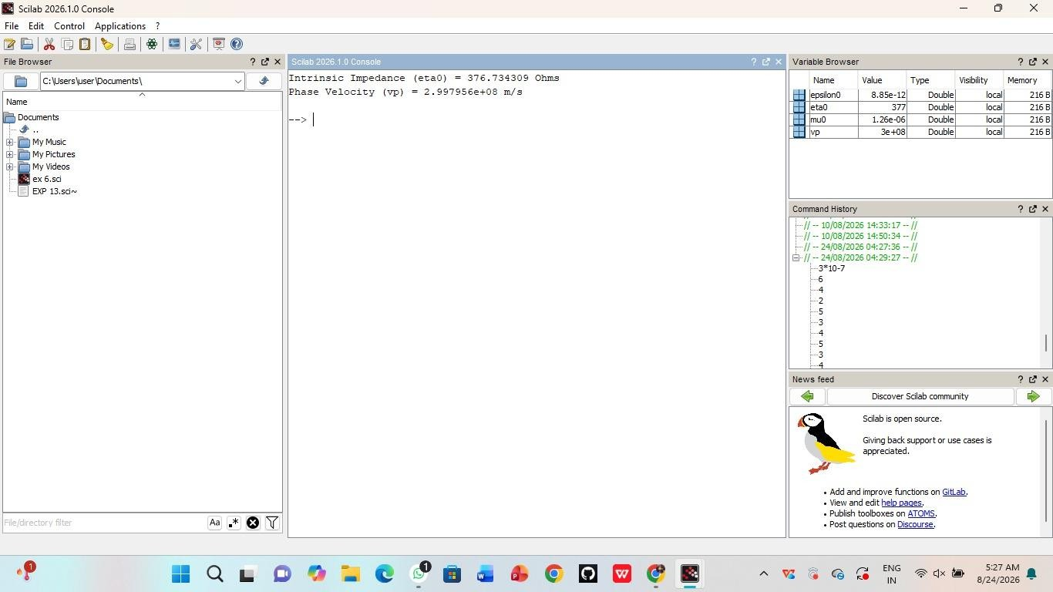
Output:
Case2:Todeterminetheintrinsicimpedanceandphasevelocityfor awavepropagatingthroughaconductivemediumlikecopper.

Program:
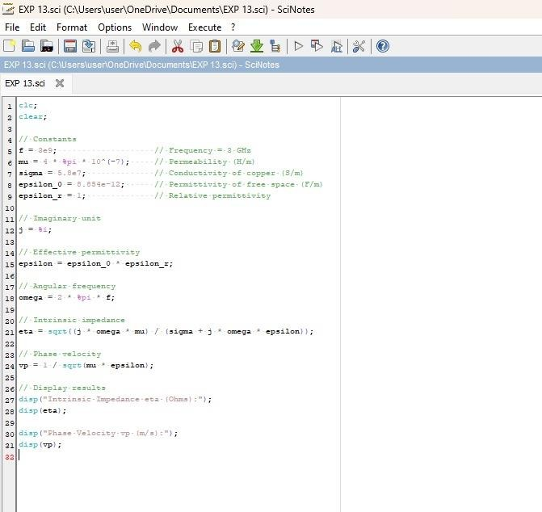

Output:
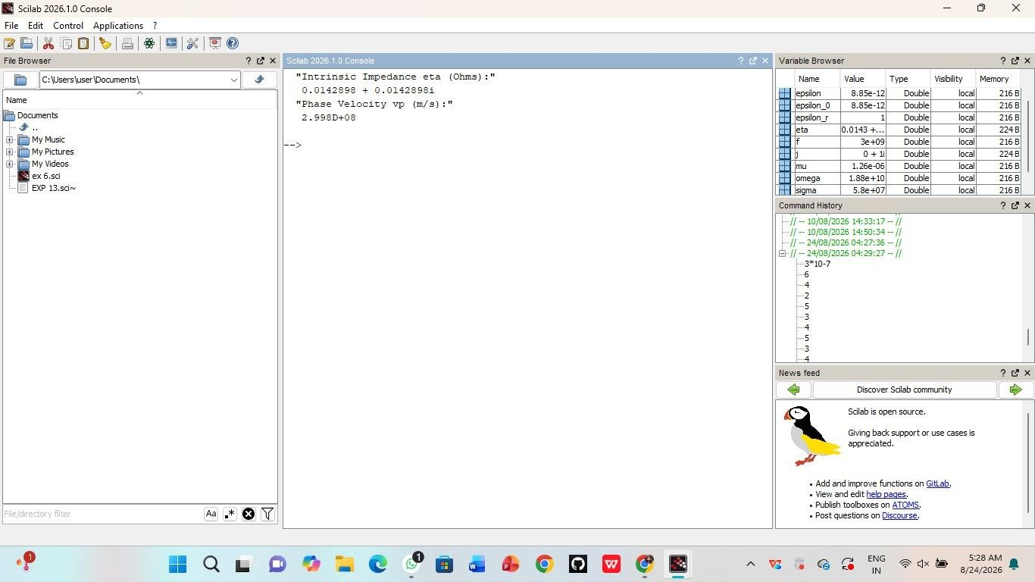
Case 3: To determine and compare the intrinsic impedance and phase velocity of electromagnetic waves propagating through differentmedia:Vacuum,Air,andWater.

Program:
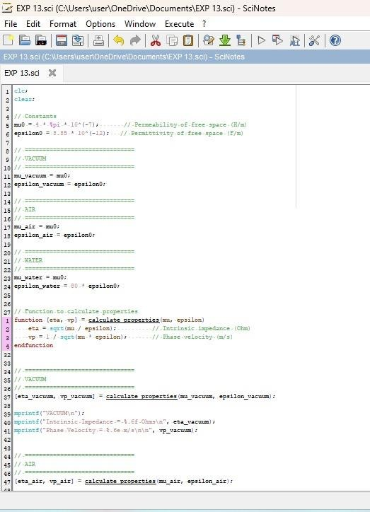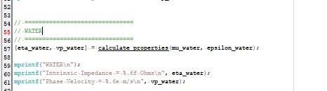

Output:

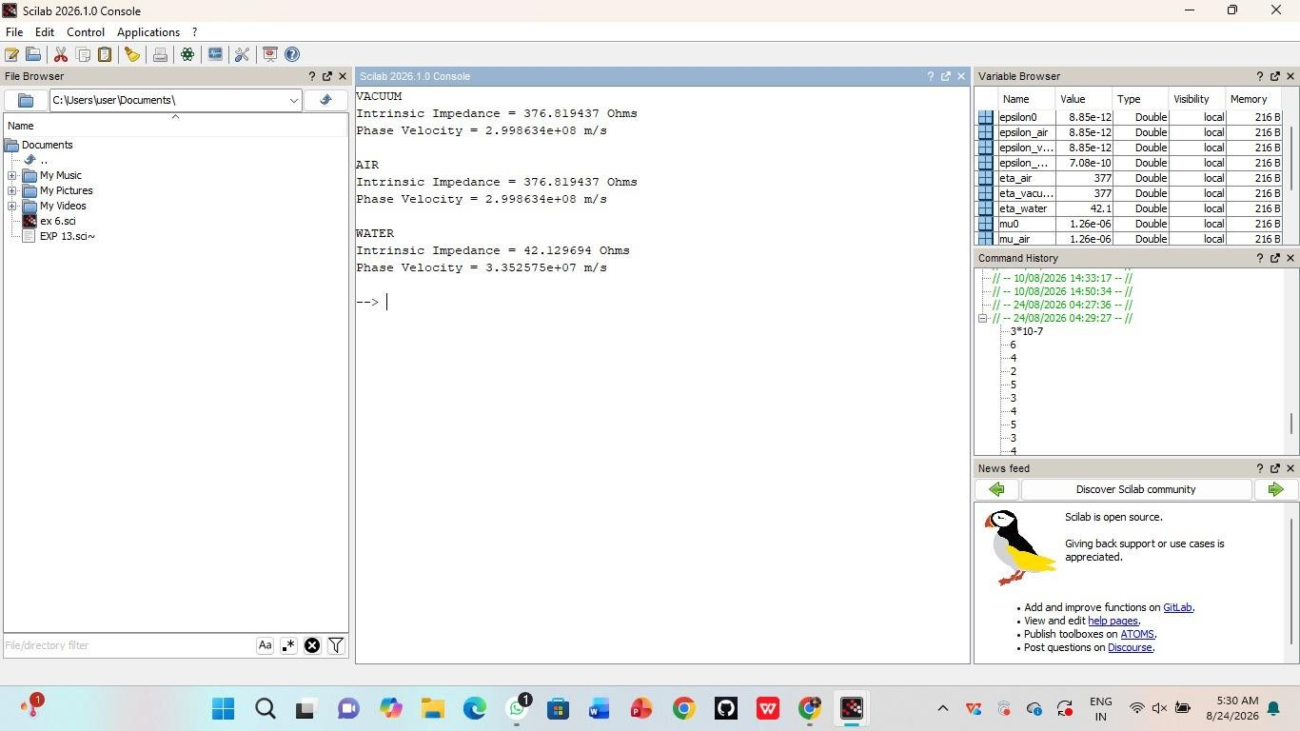

Result:
Thusthedeterminationandplottingofintrinsicandphasevelocityis performedandsuccessfullyverifiedincopper.

